Title (Times New Roman font, size 14)
First Author¹, Second Author², Third Author³ (Times New Roman font, size 12, bold). The name of the presenting author should be underlined.

¹ Address 1, City, Country, contact-author E-mail (Times New Roman font, size 10)
² Address 1, City, Country (Times New Roman font, size 10)
³ Address 1, City, Country (Times New Roman font, size 10)

Introduction (Times New Roman font, size 12, bold). Authors should use this template to prepare their abstract to be submitted to BSNM-ECRM2018. All text should be Times New Roman font, size 12 (apart from references or figure legend). Citations should be given with numbers in ^{superscript 1} and listed at the end of the abstract.

Experimental. Total abstract length should be of 1 page maximum. Any abstract exceeding 1 page will not be considered.

Results. 1 Illustration maximum (Figure or Table).
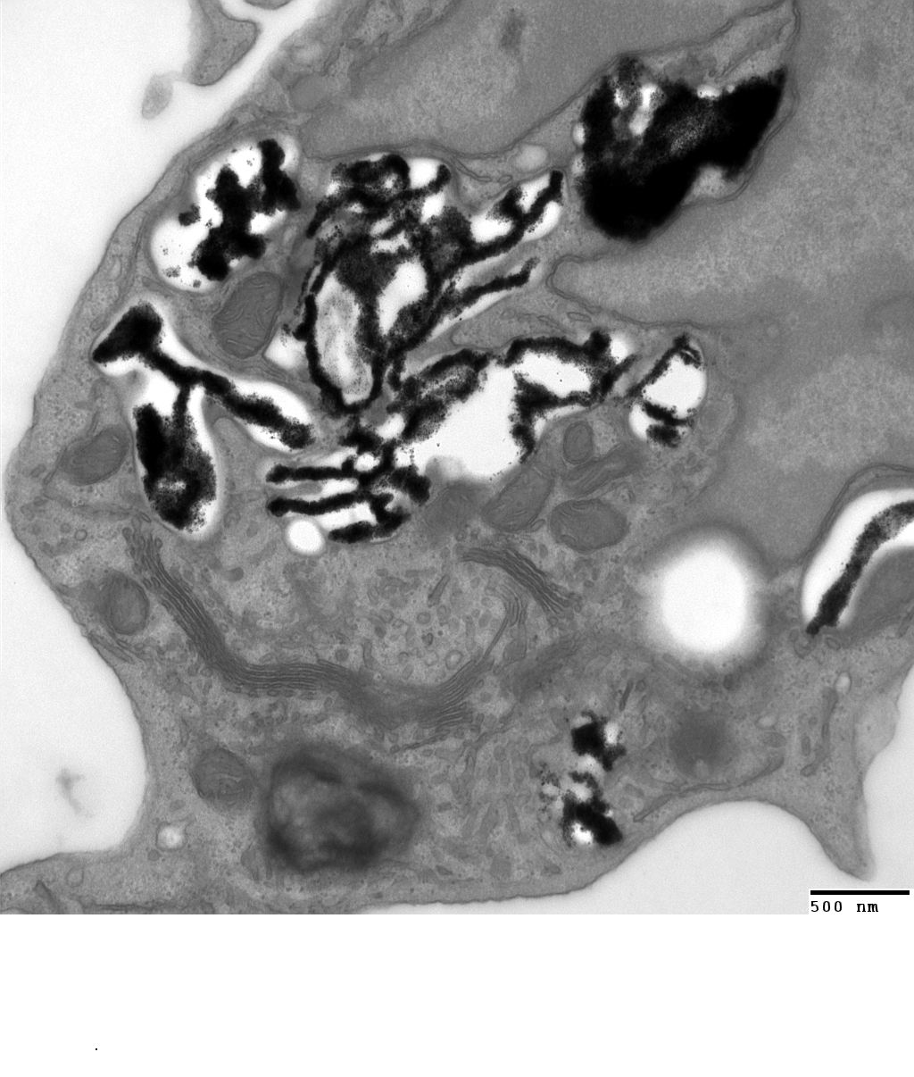

500nm

Fig. 1: Legend (Times New Roman font, size 11, italics)

Discussion and Conclusions.

References. (Times New Roman font, size 10)
[1] First Author, Second Author, Third Author, Journal 2018;volume: starting page‒ending page.
[2] First Author, Second Author, Third Author, Journal 2018;volume: starting page‒ending page.

Save your abstract as pdf file before submission. Abstracts should be submitted to bsnmecrm19@gmail.com along with your registration form

